Git hub is a reliable open source project collaboration host that is conveniently accessible to all who wish to use it. Git is also considered an industry standard, and is rather universally accepted as reliable and efficient by teams globally. Not only is it free to download but also rather widely compatible. GitHub functions on a premise that lets uses openly share projects completely free, with the option to buy repositories for private projects. This ease of access both in the free installed application and in browser and lack of any mandatory fees makes it ideal for our small programming team to coordinate on the project at hand, namely the Java coded converter.

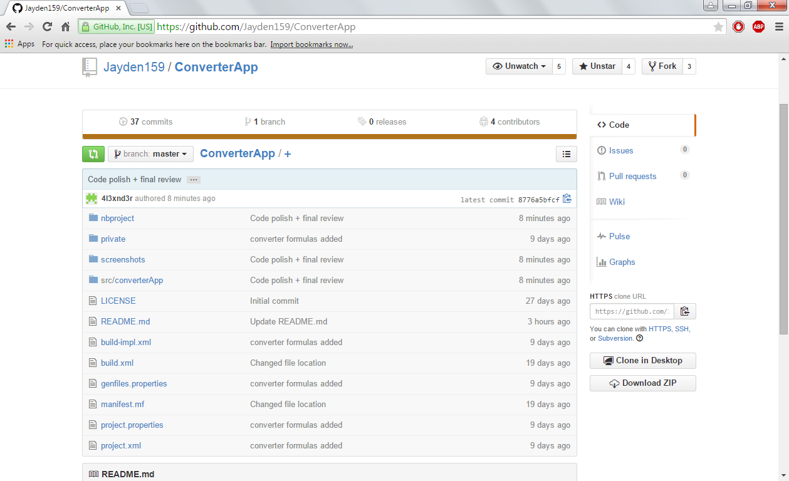The interface is simple yet intuitive, easy to understand. Notifications stack for each commit made by another user and new pushes can be synced quickly and easily, so long as two commits aren’t made at the same time and overwrite each other. Git also tracks data and uploads so it’s not hard to pinpoint when most edits were committed and by who, it’s also simple to revert back if a commit was unintentional or counterproductive.

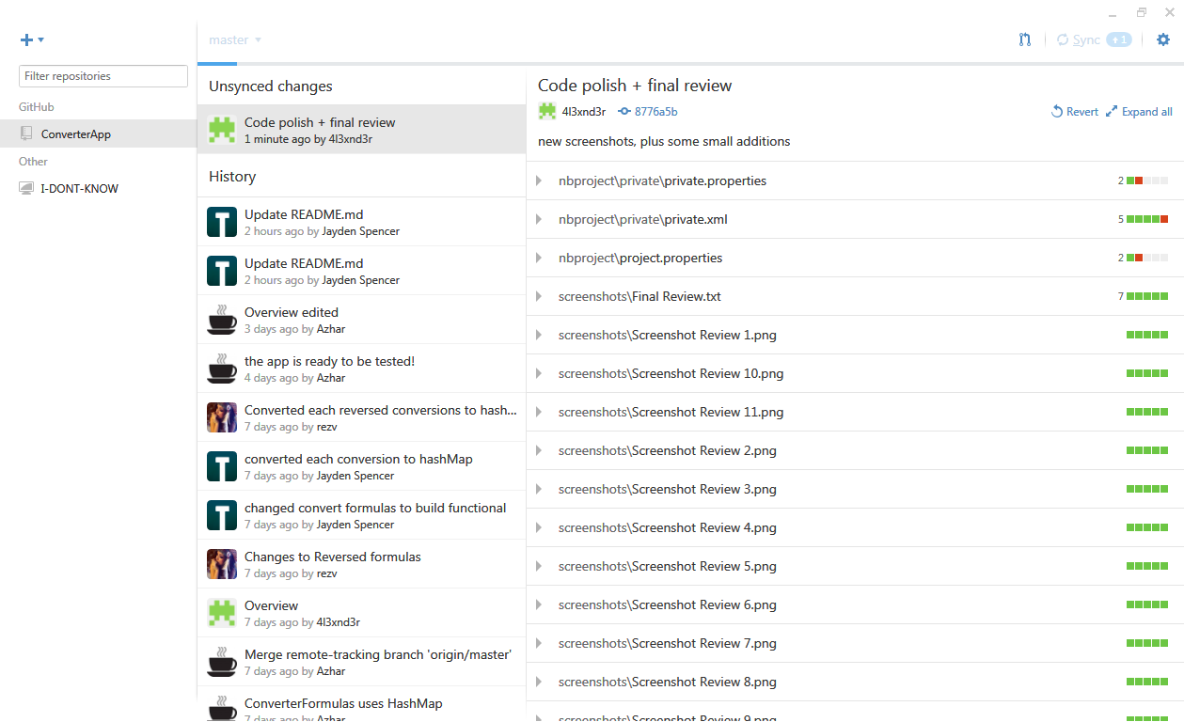

o